32.6: a) direction.
b)
c) Since the magnetic field is in the 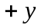-direction, and the wave is propagating in the -direction, then the electric field is in the -direction 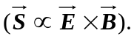 So:

